Examples of using the UCSC Table browser to download datasets used in the paper:

Bioinformatics pipeline to guide late-onset Alzheimer’s disease (LOAD) post-GWAS studies: Prioritizing **transcription regulatory variants within LOAD associated regions**

By Michael W. Lutz and Ornit Chiba-Falek

These steps are used, as illustrated in Figure 1 of the paper, to implement the bioinformatics pipeline. Intermediate steps, to construct the analysis datasets are done using the software package JMP (SAS Institute, Cary NC) to perform the table joins and subsetting operations needed to implement the bioinformatics pipeline.

UCSC Table browser settings to retrieve chromatin state segmentation information from the Roadmap Consortium database. This step is used to identify active enhancers in relevant brain regions affected in late onset Alzheimer’s disease: hippocampus middle, inferior temporal lobe and mid frontal lobe.

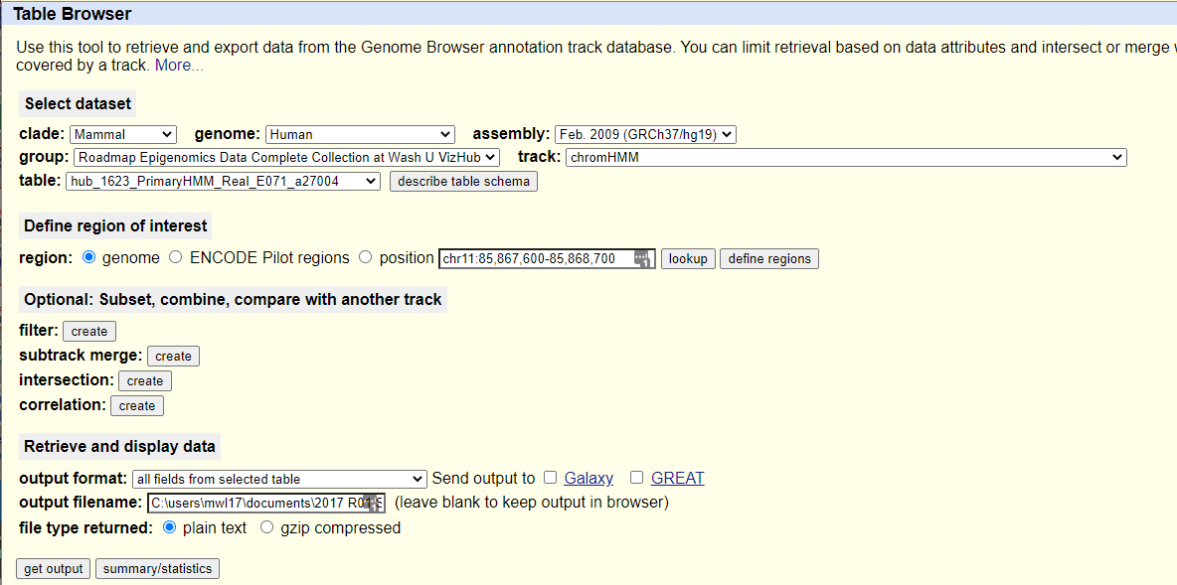

UCSC Table browser settings to identify common SNPs in the enhancer elements.

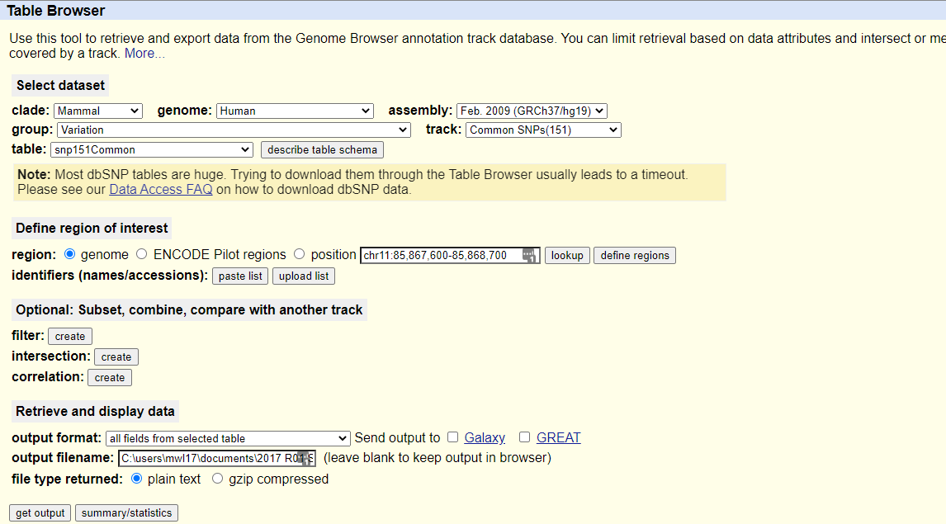

UCSC Table browser settings to download GTEx gene expression data for brain tissues.

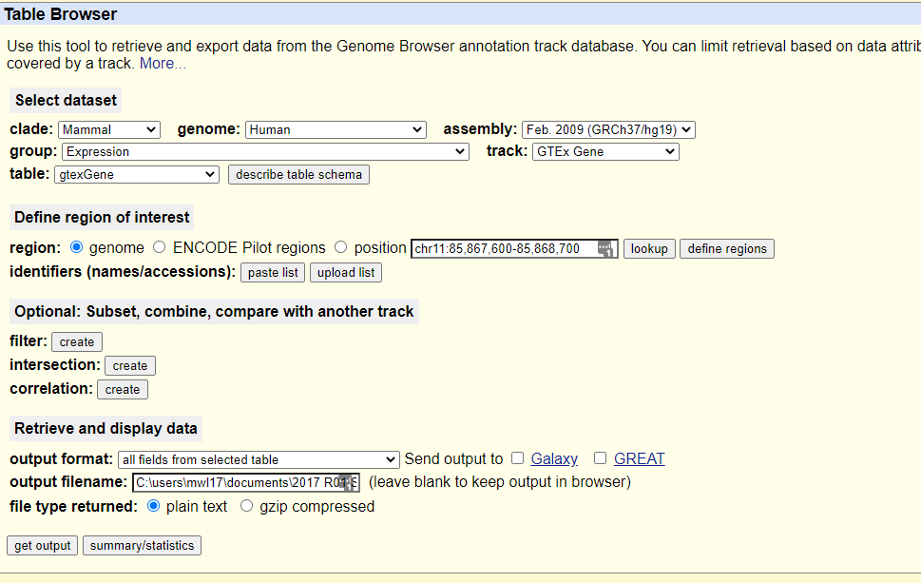

UCSC Table browser settings to load ChIP-seq data from to confirm the likelihood of each TF to bind at the predicted site within the LOAD-associated enhancer.

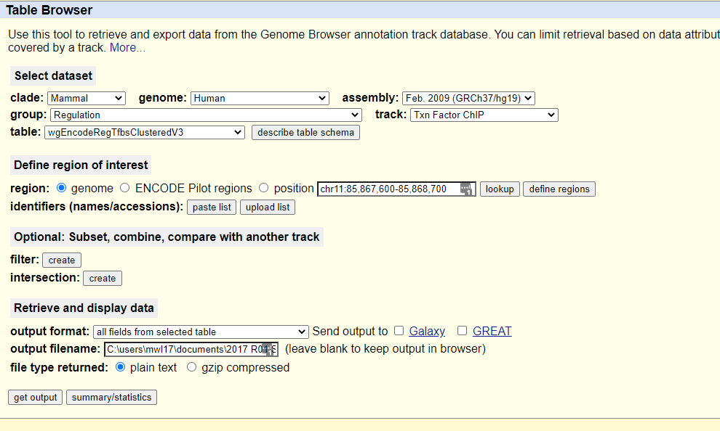

Example of single tissue eQTL analysis using GTEX

